**

SCHOOL OF ELECTRICAL AND ELECTRONIC ENGINEERING

Bachelor of Engineering (Hons) BE in Elect/Cont/Comm/Comp Eng

Program Code: (DT021A)

<YEAR 4>

Name of Module: ([Thermodynamics, ENER4601](https://brightspace.tudublin.ie/d2l/home/179100))

**TU Dublin – Grangegorman**

**Refrigeration Rig Experiment**

Student Name: _Talha Tallat, D18124645 ______________

Academic Lecturer:  _John McGrory___________________ _

Submission Date: _17th December 2021___________________

Table of Contents

1. Experiment Aim 3

1.1. Introduction 3

2. Laboratory Tasks 3

2.1. Tasklist 3

3. Procedure 4

3.1. Test 1 5

3.1.1. Evaporator Pressure 6

3.1.2. Condenser Pressure 6

3.1.3. Evaporator Cofficient performance 6

3.1.4. Condenser Cofficient performance 7

3.2. Test 2 8

3.2.1. Evaporator Pressure 9

3.2.2. Condenser Pressure 9

3.2.3. Evaporator Cofficient performance 9

3.2.4. Condenser Cofficient performance 9

3.3. Test 3 11

3.3.1. Evaporator Pressure 12

3.3.2. Condenser Pressure 12

3.3.3. Evaporator Cofficient performance 12

3.3.4. Condenser Cofficient performance 12

3.4. Experiment Question 13

4. Conclusion 14

5. References 14

Table of Figures

Figure 1 - Enthalpie graph of refrigeration rig experiment test 1[1] 5

Figure 2 - Enthalpie graph of refrigeration rig experiment test 2 [1] 8

Figure 3 - Enthalpie graph of refrigeration rig experiment test 3 [1] 11

List of Table

Table 1 - Assigned Experiment data #3 4

# Experiment Aim

Demonstrating the thermodynamic basic principle of a vapour compression refrigeration cycle.

## Introduction

This experiment rig is designed for the study of thermodynamics of vapour compression refrigeration cycle by way of experimentation and testing during laboratory. It has a facility to measure various parameters for experimentation.

There are four Main Refrigeration cycle components

* The compressor.
* The condenser.
* The expansion device.
* The evaporator.

# Laboratory Tasks

## 2.1. Tasklist

1. View the “Refrigeration Rig Overview” Video. This video describes the operation of the whole rig and all its parts. The icing up of the thermal expansion valve is discussed and the flow of the refrigerant.

2. View the “Refrigeration Rig Experiment” Video. This video goes through the calculations needed for this experiment using a sample set of results.

3. Your submission:

a) Beside your name is your assigned Experiment Data #1, #2 or #3. You must use your assigned data. All the work must be your own.

b) Complete the calculations for all three tests in your Experiment Data #. Clearly show your work, calculations, steps and graphs used.

c) Plainly state if the coefficient of performance that is calculated is as you would expect!   
Explain using your results the relationship between the shape of the pressure – enthalpy diagram and its correlation to the resultant value of the coefficient of performance.

d) Answer the following questions:   
a. Why is the term of coefficient of performance used rather than efficiency?

b. What would happen if the heat absorbed by the evaporator is more than the   
heat dissipated by the condenser?

c. The refrigerant oil rotameter (flow meter for refrigerant) just before the   
Thermal Expansion Valve shows a clear liquid flowing, but the compressor is   
compressing a gas. Explain what is happening here.

# Procedure

Table 1 - Assigned Experiment data #3

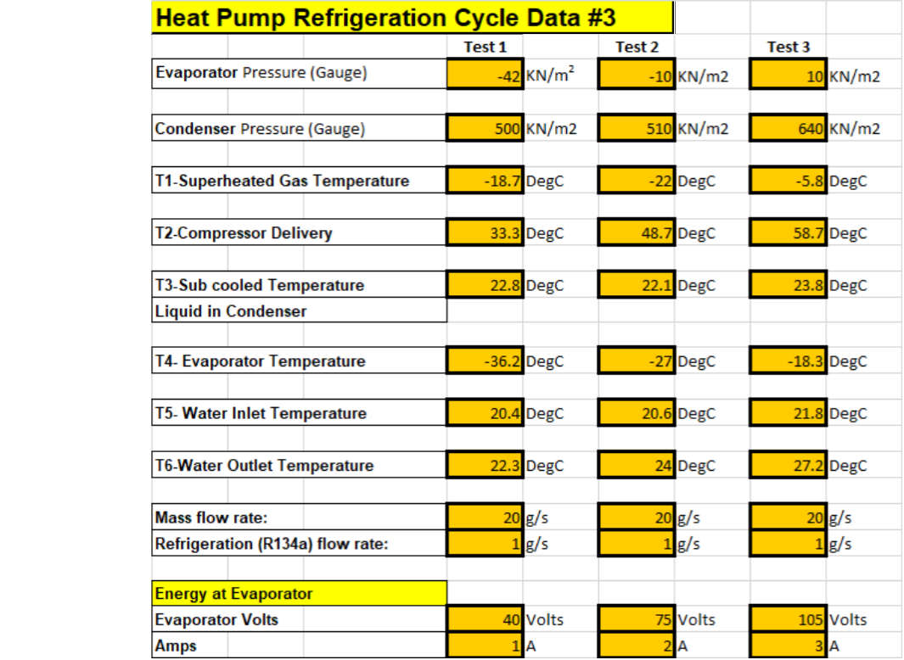

## 3.1. Test 1

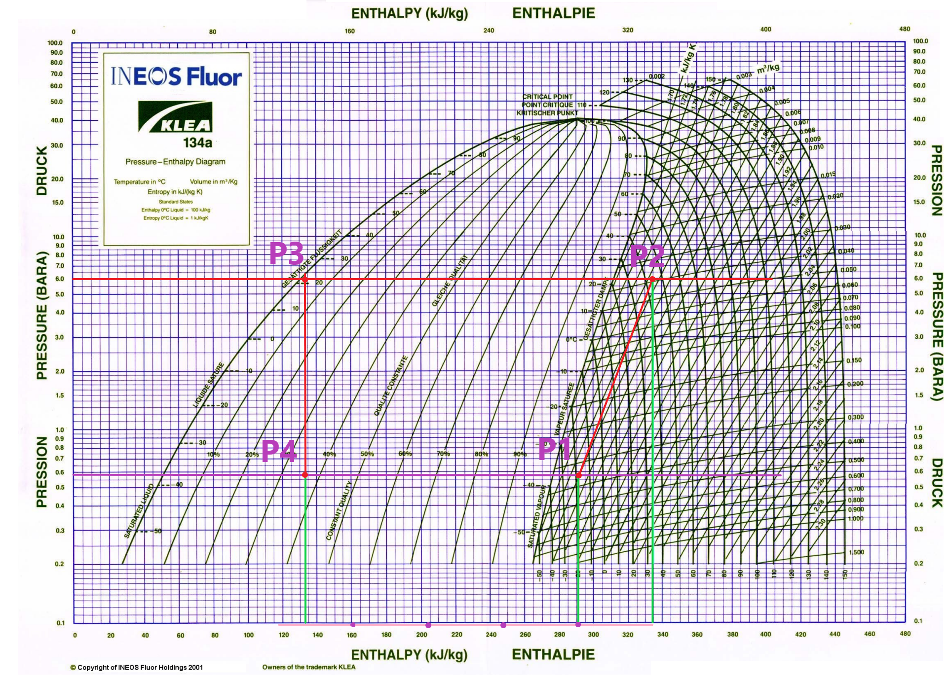

Figure 1 - Enthalpie graph of refrigeration rig experiment test 1[1]

3.1.1. Evaporator Pressure

Taking the Evaporator pressure at the guage is $-42 KN/m^{2}$ and coverting it to bar where bar is the unit of pressure.

$$1 bar= 1 ×{10}^{5}N/m^{2}$$

$$1KN/m^{2}= 1 ×{10}^{3}N/m^{2}$$

So we can divide by 100 in order to covert $KN/m^{2}$ to bar.

$$\frac{-42 KN/m^{2} }{100}=-0.42 bar Gauge pressure$$

However, finding the abslout pressure, since we are above certain see level therefore, taking in count of a constant atmospheric pressure which is 1 bar.

$$abslout pressure= Gauge pressure+atmospheric pressure$$

$$-0.42+1=0.58 bar ABS Pressure$$

3.1.2. Condenser Pressure

Taking the Condenser pressure at the guage is $500 KN/m^{2}$ and coverting it to bar.

$$\frac{500 KN/m^{2} }{100}=5 bar$$

$$abslout pressure= Gauge pressure+atmospheric pressure$$

$$5+1=6 bar ABS Pressure$$

3.1.3. Evaporator Cofficient performance

Cofficient performance of the evaporator is evaportaotor rate deividided by the compracer energy put in.

$${COP}_{E}=\frac{h_{1}- h_{4}}{h_{2}- h_{1}}$$

Enthalpy values are taken from the graph in figure 1, which are:

$$h_{3}=h_{4}≈133.5 kj/kg$$

$$h_{1}≈291 kj/kg$$

$$h_{2}≈335 kj/kg$$

$${COP}_{E}=\frac{291- 133.5}{335- 291}=3.58$$

3.1.4. Condenser Cofficient performance

The Cofficient performance of the condenser is usually one more than the evaporator coefficient performance. We can calculate to find it.

$${COP}_{C}=\frac{h_{2}- h_{3}}{h_{2}- h_{1}}$$

$${COP}_{E}=\frac{335- 133.5}{335- 291}=4.58$$

The output of Cofficient performance of the condenser calculats to be 3.58 where the evaporator coefficient performance is 4.58 which is 1 higher as expected.

## 3.2. Test 2

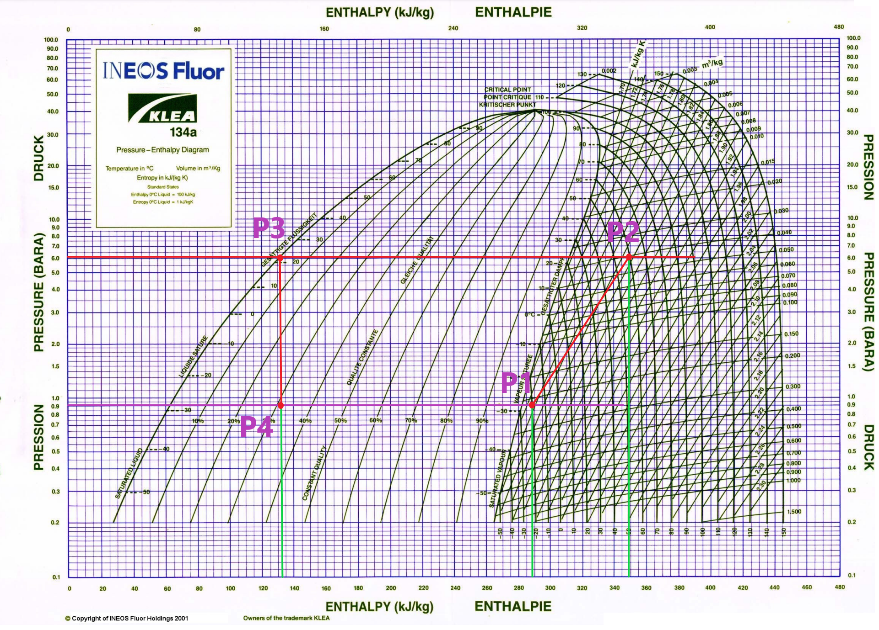

Figure 2 - Enthalpie graph of refrigeration rig experiment test 2 [1]

3.2.1. Evaporator Pressure

In test 2, taking the Evaporator pressure at the guage is $-10 KN/m^{2}$ and coverting it to bar where bar is the unit of pressure.

So we can divide by 100 in order to covert $KN/m^{2}$ to bar.

$$\frac{-10 KN/m^{2} }{100}=-0.1 bar Gauge pressure$$

$$abslout pressure= Gauge pressure+atmospheric pressure$$

$$-0.1+1=0.9 bar ABS Pressure$$

3.2.2. Condenser Pressure

In test 2, taking the Condenser pressure at the guage is $510 KN/m^{2}$ and coverting it to bar.

$$\frac{510 KN/m^{2} }{100}=5.1 bar$$

$$abslout pressure= Gauge pressure+atmospheric pressure$$

$$5.1+1=6.1 bar ABS Pressure$$

3.2.3. Evaporator Cofficient performance

Cofficient performance of the evaporator is evaportaotor rate deividided by the compracer energy put in.

$${COP}_{E}=\frac{h_{1}- h_{4}}{h_{2}- h_{1}}$$

In test 2, Enthalpy values are taken from the graph in figure 2, which are:

$$h_{3}=h_{4}≈132.5 kj/kg$$

$$h_{1}≈288.5 kj/kg$$

$$h_{2}≈348.5 kj/kg$$

Cofficient performance of the evaporator:

$${COP}_{E}=\frac{288.5- 132.5}{348.5- 288.5}=2.6$$

3.2.4. Condenser Cofficient performance

In test 2, the Cofficient performance of the condenser is usually one more than the evaporator coefficient performance. We can calculate to find it.

$${COP}_{C}=\frac{h_{2}- h_{3}}{h_{2}- h_{1}}$$

$${COP}_{E}=\frac{348.5 - 132.5}{348.5 - 288.5}=3.6$$

The output of Cofficient performance of the condenser calculats to be 2.6 where the evaporator coefficient performance is 3.6 which is 1 more greater as expected.

## 3.3. Test 3

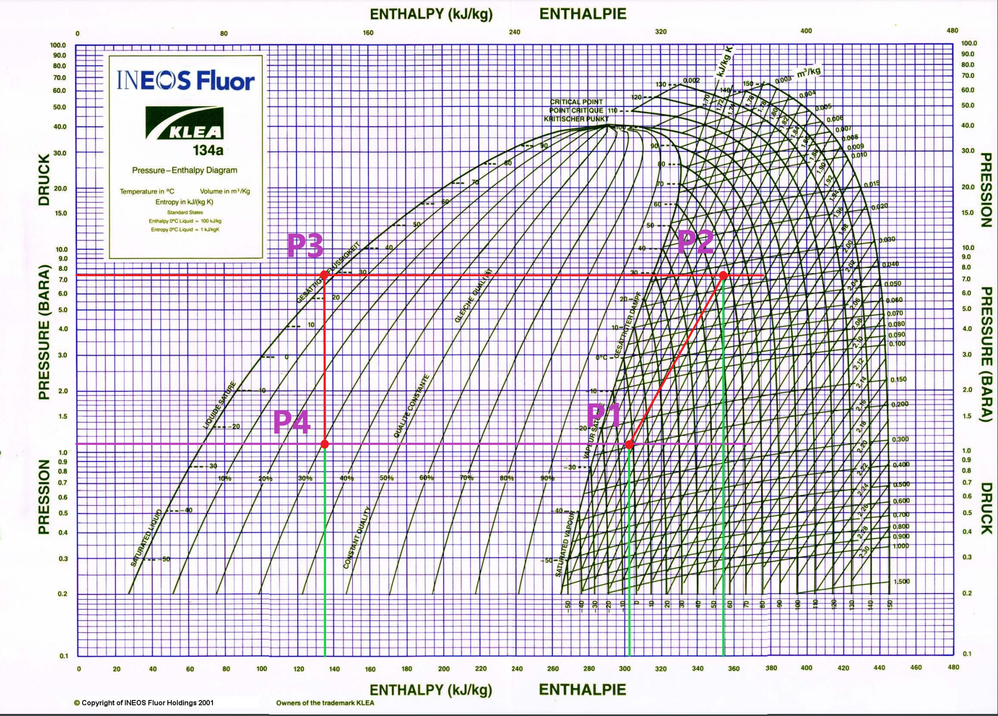

Figure 3 - Enthalpie graph of refrigeration rig experiment test 3 [1]

3.3.1. Evaporator Pressure

In test 3, taking the Evaporator pressure at the guage is $10 KN/m^{2}$ and coverting it to bar where bar is the unit of pressure.

So we can divide by 100 in order to covert $KN/m^{2}$ to bar.

$$\frac{10 KN/m^{2} }{100}=0.1 bar Gauge pressure$$

$$abslout pressure= Gauge pressure+atmospheric pressure$$

$$0.1+1=1.1 bar ABS Pressure$$

3.3.2. Condenser Pressure

In test 3, taking the Condenser pressure at the guage is $640 KN/m^{2}$ and coverting it to bar.

$$\frac{640 KN/m^{2} }{100}=6.4 bar$$

$$abslout pressure= Gauge pressure+atmospheric pressure$$

$$6.4+1=7.4 bar ABS Pressure$$

3.3.3. Evaporator Cofficient performance

Cofficient performance of the evaporator is evaportaotor rate deividided by the compracer energy put in.

$${COP}_{E}=\frac{h_{1}- h_{4}}{h_{2}- h_{1}}$$

In test 3, Enthalpy values are taken from the graph in figure 1, which are:

$$h_{3}=h_{4}≈135 kj/kg$$

$$h_{1}≈302.5 kj/kg$$

$$h_{2}≈358.5 kj/kg$$

$${COP}_{E}=\frac{302.5- 135}{358.5- 302.5}=3$$

3.3.4. Condenser Cofficient performance

The Cofficient performance of the condenser is usually one more than the evaporator coefficient performance. We can calculate to find it.

$${COP}_{C}=\frac{h_{2}- h_{3}}{h_{2}- h_{1}}$$

$${COP}_{E}=\frac{358.5- 135}{358.5- 302.5}=4$$

The output Cofficient performance of the condenser calculats to be 3 where the evaporator coefficient performance is 4 which is 1 higher as expected.

## 3.4. Experiment Question

Dry bulb temperature (T1) of air entering base of the column and Wet bulb temperature (T2) of air entering the base of a column.

Dry bulb temperature (T3) of air at the exit from a column and Wet bulb temperature (T4) of air at the exit from the column.

T1 is hotter than T3, since we are dissipating energy the outlet air temperature T3 should be hotter than the inlet air temperature T1! it may seem unusual, however, the idea of evaporating cooling is where an object that is damped evaporates moisture and its colder than the environment that is its in.

# 4. Conclusion

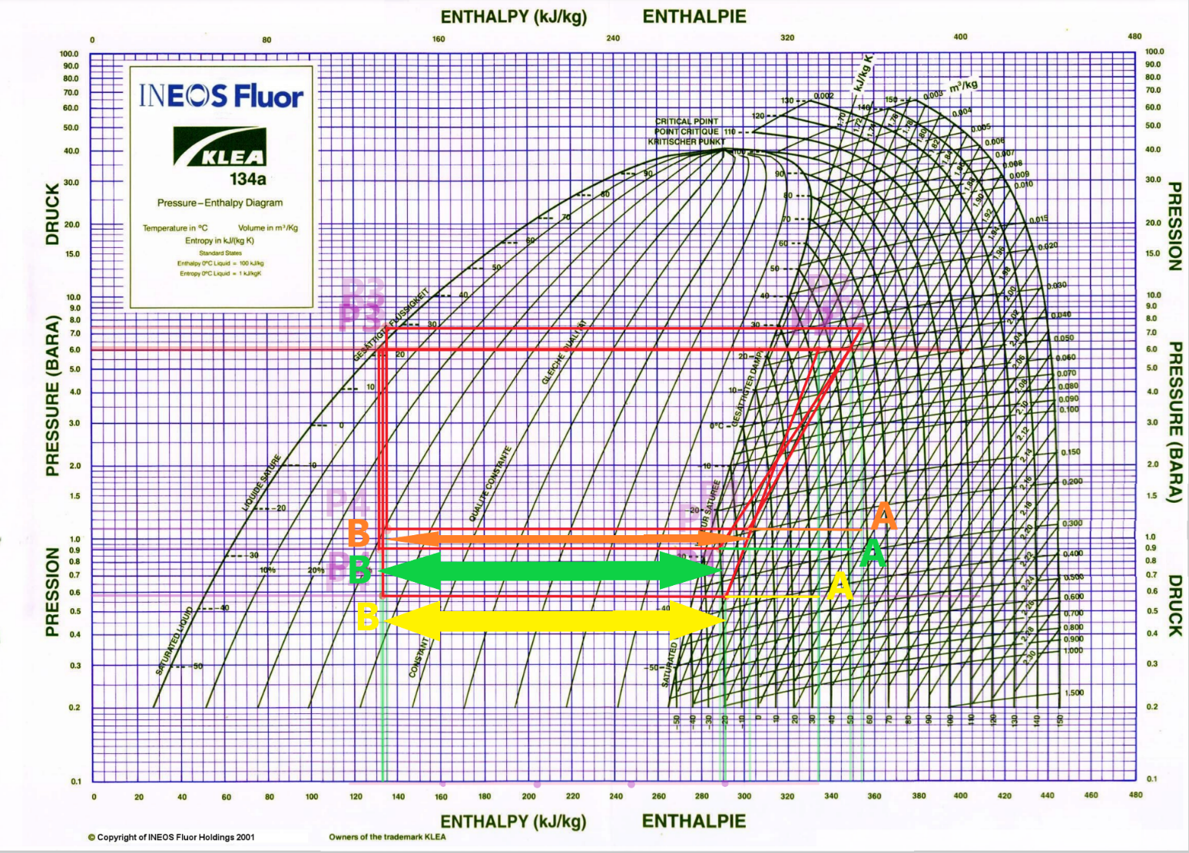

After carrying out the test 2 we notice that the angle changed then it has an effect on the coefficient.  
  
Energy balance:

# 5. References

**[1]** "PRESSURE – ENTHALPY DIAGRAM", *Educypedia.karadimov.info*, 2021. [Online]. Available: http://educypedia.karadimov.info/library/PED_Klea134a.pdf. [Accessed: 10- Dec- 2021]